AEL Enrollments Grantee Report
Tableau Report User Documentation
Screen Reader Users
- Some dashboards will have areas that read as graphics when they are just titles.
- The operator for “Performance Status” (-, +) on the Performance tab may not read correctly for P performance status.
- For the download, which requires user credentials, follow the screen reader instructions to download row level data.
- For the Overview, the best options to download are by PDF for a formatted document and CSV for summary data (where the option exists.
Table of Contents
Methodology 3
Data Source 3
Data Processing 3
Calculations and Definitions 3
Grantee Names and IDs 3
Performance Targets 4
Enrollment Measures and Fund Codes 4
Demographic Fields 4
Limitations 5
Overview 6
Fields Used 8
Download Instructions 20
Data File Download 20
Step 1. Set Filters 20
Step 2. Select Data 20
Step 3. Click “Download” 20
Step 4. Click “Data” 20
Step 5. Download File 21
Step 6. Open File 21
Dashboard PDF Download 22
Step 2 22
Step 3 22
Step 4 23
Step 5 23

Methodology

Data Source
The data used to create this report is generated in TEAMS. Each night, the data stored in the TEAMS database is extracted and loaded into the Information Innovation & Insight (I|3) Enterprise Data Warehouse (EDW).

Data Processing
Once the data has been loaded into the EDW, it is processed using the standard AEL methodology. This process includes merging tables, formatting data types, and creating calculated fields. Calculations for enrollments and performance are calculated in Tableau.

Calculations and Definitions
- Participant: An individual with 12 or more direct contact hours within a period of participation (POP).
- Reportable Individual: An individual with less than 12 hours of direct contact hours during a POP.
- Distance Learner: An individual with more proxy hours than direct hours for the program year.
- Enrollments: Calculated by counting each distinct participant for each Grantee.
- Performance Percentage: Calculated by dividing the number of enrollments by the Grantee's program year target.
- Proportional Performance Percentage: Calculated by dividing the number of enrollments by the Grantee's proportional monthly target.
- Performance Status: Performance percentage is categorized using a calculated field in Tableau based on the following criteria: if the performance percentage < 95% then the performance level is "-P", if the performance percentage >= 95% and < 105% then the performance level is "MP", and if the performance percentage >= 105% the performance level is "+P".

Grantee Names and IDs
Grantee names and IDs are updated each program year to accurately reflect the current program year's student distribution. When a Grantee changes, the name and ID are updated based on the old Grantee ID and county. This dashboard uses Grantee names and IDs for program year (PY) 2022.

Performance Targets
This dashboard uses performance targets for program years 2019, 2020, 2021, and 2022. These targets are applied to performance calculations based on the program year. Monthly targets are calculated by dividing the program year target by 12.

Enrollment Measures and Fund Codes
Below are the fund codes used for each program year available in the Enrollments dashboard.
Only fund codes with active students will be shown in visualizations. For example, if Site A for Grantee 999 had 0 students enrolled using fund code 19, that fund code would not be displayed in the “Fund Code” filter on the Enrollments tab.

PY19
- Total Enrollments: 1, 5, 8, 17, 19, 21, 23, 33, 34, 36, 37, 40, 43, 50, 54, 55, and 56
- EL Civics: 50
- Integrated EL Civics: 40
- Intensive: 19, 23, 34, 37, and 56
- IET: 17, 33, and 54

PY20
- Total Enrollments: 1, 3, 5, 8, 17, 19, 21, 23, 27, 29, 30, 31, 33, 34, 36, 37, 40, 43, 50, 54, 55, 56, and 57
- EL Civics: 50
- Integrated EL Civics: 40
- Intensive: 19, 23, 26, 28, 34, 37, and 56
- IET: 17, 27, 33, 49, and 54

PY21
- Total Enrollments: 1, 5, 8, 17, 19, 21, 23, 33, 34, 36, 37, 40, 43, 47, 50, 54, 55, 56, 57, 58, and 59
- Intensive: 19, 23, 34, 37, 56, 58, and 59
- IET: 17, 33, 40, and 54

PY22
- Total Enrollments: 1, 5, 8, 17, 19, 21, 23, 33, 34, 36, 37, 40, 43, 47, 50, 54, 55, 56, 57, 58, and 59
- Intensive: 19, 23, 34, 37, 56, 58, and 59
- IET: 17, 33, 40, and 54

PY23
- Total Enrollments: 1, 5, 8, 17, 19, 21, 23, 33, 34, 36, 37, 40, 43, 50, 54, 55, 56, and 57
- EL Civics: 50
- EL Civics IET: 40
- IET: 17, 33, and 54
- Intensive: 19, 23, 34, 37, and 56

Full List of Fund Codes
FUND CODE NUMBER | FUND CODE NAME
1 | Basic AEL (AEFLA)
2 | Even Start
3 | Basic AEL (TANF)
4 | English Literacy Civics Education
5 | Basic AEL (Corrections)
6 | Family Literacy Challenge grant (ended 6.30.05)
7 | JTPA (ended 6.30.05)
8 | Local
9 | Other
10 | Windham ISD Funding
11 | Higher Ed IPAES - HB 2237 GR Funds
12 | State & Federal C4 (ended 6.30.13)
13 | TANF C4 (ended 6.30.13)
14 | WIA Incentive Grant I (ended 6.30.13)
15 | WIA Incentive Grant II (ended 6.30.13)
16 | Other State Funds
17 | IET (AEFLA)
18 | IET (Incentive)
19 | Work Based (AEFLA)
20 | Work Based (Incentive)
21 | Transitions Classes (AELFA)
22 | Distance Learning (AEFLA)
23 | ESL for Professionals (AEFLA)
24 | TACSI (State Leadership)
25 | Accelerate Texas
26 | Work Based 30hrs (AEFLA)
27 | IET (TANF)
28 | Work Based 30hrs (TANF)
29 | Transitions Classes (TANF)
30 | ESL for Professionals (TANF)
31 | Work Based (TANF)
32 | Distance Learning (TANF)
33 | IET (Local)
34 | Work Based (Local)
35 | Work Based 30hrs (Local)
36 | Transitions Classes (Local)
37 | ESL for Professionals (Local)
38 | Distance Learning (Local)
39 | Distance Learning (EL Civics)
40 | IET (EL Civics)
41 | Work-based (EL Civics)
42 | Work-based 30 hours (EL Civics)
43 | EL Civics (AEFLA)
44 | Site-Based (AEFLA)
45 | Site-Based (State Leadership)
46 | TACSI (AEFLA)
47 | TWC Accelerate Texas (AEFLA)
48 | TWC Accelerate Texas (State Leaders)
49 | THECB Integrated Career Pathway
50 | EL Civics (EL Civics)
51 | Distance Learning (Site-Based)
52 | ATB (State Leadership)
53 | ATB (AEFLA)
54 | IET (Corrections)
55 | Transitions (Corrections)
56 | Re-Entry (Corrections)
57 | MACC (State Leadership)
58 | Work Based (EL Civics)
59 | ESL Professional (EL Civics)

Demographic Fields
Demographic fields are calculated for participants each program year and can be applied to visualizations that count participants using filters. Applying demographic filters to performance visualizations will have no effect.
Status demographic fields, such as "Cultural Barriers" and "English Language Learner," on the Participant View tab provide additional demographic information for participants. These fields are based on WIOA additional reportable characteristics.

Limitations
Unlike the Excel version of the Enrollments report which used aggregated data, this Tableau version uses student level data. One limitation associated with using student level data is that values, such as targets or fund codes, will only display if there is a row in the data associated with those values. For example, if Grantee 5XX did not have any students enrolled in an Intensive program for the PY, no PY target would be displayed in the dashboard.
To protect student’s personal identifiable information, this dashboard includes row level security. This security may cause some filters to default to a selection with no associated values. If the filter text is in parentheses, then a new, applicable value must be selected. The exception to this is the “All” option, which will always be in parentheses.

Overview
The AEL Enrollments Grantee report includes four dashboard tabs, including:
Getting Started: This dashboard includes welcome message, general information about the AEL Enrollments Grantee report, a link to the Statewide version of the AEL Enrollments report, and links to documentation, including the Tableau User documentation and this document.
Enrollments: This dashboard includes five visualizations that provide information about enrollments.
- The top left visualization, a big number, includes the title and number of participants for the Enrollment Measure currently selected in the filters.
- The middle left visualization, another big number, will always display the total number of enrollments and does not change when Enrollment Measure or Fund Code filters are changed.
- The bottom left visualization is a map of the Counties Served and includes the county name, Board number, Board name, a count of active participants, a count of reportable individuals, and a count of distance learners.
- The top right line graph comparing the number of active participants (blue line) to number of new periods of participation (red line) for the selected program year.
- The table in the bottom right includes counts of the number of students with less than 12 direct contact hours and participants with 12 or more direct contact hours by Provider, Site, and Class.
Users can filter by Enrollment Measure, Fund Code, Grantee, Provider, Program Year, Month, Age, Gender, Race, Education, and Education Location.
Performance: This dashboard includes five visualizations related to enrollments performance.
- The top left visualization is a big number with the title of selected Enrollment Measure. This visualization provides a count of the number of participants for the selected enrollment measure.
- The second-from-the-left, top visualization, titled PY Target, is a big number that shows the program year’s target for the selected Enrollment Measure.
- The third-from-the-right, top visualization, title Percent of PY Target, is a big number that shows the percent of the program year’s target that has been reached for the selected Enrollment Measure.
- The far-right, top visualization, titled PY Performance Status, provides the performance status for the selected Enrollment Measure for the Program Year. See the Performance Status bullet in the Methodology section for more information on how this is calculated.
- The bottom visualization bar chart titled Proportional Performance by Month. It shows the count of participants each month (blue bars) compared to the expected monthly performance level (red line).
Users can filter by Enrollment Measure, Fund Code, Grantee, Program Year, Month, Age, Gender, Race, Education, and Education Location. Performance is only calculated at the grantee level. PY Target, Percent of PY Target, and PY Performance Status will not be accurate when applying AGE, Gender, Race, Education, and Education Location filters because targets are not set for these subsets of the population.
Participant View: This dashboard includes one visualization, a table, that allows the user to get participant information based on the selected values of 21 filters. The table includes Participant ID, Participation ID, Class Name, a count of direct contact hours, a count of proxy contact hours, and a count of training contact hours.
Users can filter by Enrollment Measure, Fund Code, Grantee, Provider, Site Name, Program Year, Month, Age, Gender, Race, Education, Education Location, Cultural Barriers status, Disability status, English Language Learner (ELL) status, Exoffender status, Foster Youth status, Incarcerated status, Low Income status, and Veteran status.

Fields Used
TABLEAU COLUMN NAME | ORIGINAL SOURCE | EDW TABLE NAME | EDW COLUMN NAME | DESCRIPTION
Age Range | Calculated in the EDW | REPORTING_TEC | AGE_RANGE | Creates age range category based on participant's age at participation_start_date. Categories include:  16-18  19-24  25-44  45-54  55-59  60+
Board Name | AEL Enrollments Target table in EDW | REPORTING_TEC | BOARD_NAME | LWDA Board Name
Board Num | AEL Enrollments Target table in EDW | REPORTING_TEC | BOARD_NUM | LWDA Board Number
Class Date | TEAMS | REPORTING_TEC | CLASS_DATE | Date student/participant attended class
Class Direct Rtotal | Calculated in the EDW | REPORTING_TEC | CLASS_DIRECT_RTOTAL | Running total of direct contact hours by class for each period of participation (POP)
Class ID | TEAMS | REPORTING_TEC | CLASS_ID | Unique ID designation for class
Class Month | TEAMS | REPORTING_TEC | CLASS_MONTH | Numerical Month class date took place
Class Name | TEAMS | REPORTING_TEC | CLASS_NAME | Name of class
Class Proxy Rtotal | Calculated in the EDW | REPORTING_TEC | CLASS_PROXY_RTOTAL | Running total of proxy contact hour by class for each POP
Class Training Rtotal | Calculated in the EDW | REPORTING_TEC | CLASS_TRAINING_RTOTAL | Running total of training hours by class for each POP
County | Texas Counties .shp file | Texas_Counties_g.shp | Cityname2 | County name
Cultural Barriers Status | TEAMS | REPORTING_TEC | CULTURAL_BARRIERS_STATUS | Cultural barriers at program entry  0=No  1=Yes  9=Did not disclose
Disability Status | TEAMS | REPORTING_TEC | DISABILITY_STATUS | Individual with a disability  0=No  1=Yes  9=Did not disclose
Distance Learner Flag | TEAMS | REPORTING_TEC | DISTANCE_LEARNER_FLAG | If the student has more proxy hours than direct contact hours in the PY, then 1, else 0
Education Level | Calculated in the EDW | REPORTING_TEC | EDUCATION_LEVEL | Text value of education level:  • None completed  • High school diploma  • High school equivalency  • Some postsecondary education  • Postsecondary, technical, or vocational certificate  • Associate's degree  • Bachelor's degree  • Beyond bachelor's degree
ELL Status | TEAMS | REPORTING_TEC | ELL_STATUS | English language learner status at program entry  0=No  1=Yes  9=Did not disclose
Enrollment Measure | TEAMS | REPORTING_TEC | ENROLLMENT_MEASURE | Enrollment measure values include:  • Total (Total Enrollments)  • EL Civics  • IET  • Integrated EL Civics  • Intensive
Exoffender Status | TEAMS | REPORTING_TEC | EXOFFENDER_STATUS | Ex-Offender Status at Program Entry  1=Yes  0=No  9=Did not disclose
Foster Youth Status | TEAMS | REPORTING_TEC | FOSTER_YOUTH_STATUS | Foster Care Youth Status at Program Entry  1=Yes  0=No  9=Did not disclose
Fund Code Name | TEAMS | REPORTING_TEC | FUND_CODE_NAME | Funding source name
Gender Desc | Calculated in the EDW | REPORTING_TEC | GENDER_DESC | Participant’s gender: Female, Male, or Missing
Grantee ID | TEAMS | REPORTING_TEC | GRANTEE_ID | Unique code assigned to each Grantee
Grantee Name | TEAMS | REPORTING_TEC | GRANTEE_NAME | Grantee’s name
Incarceration Status | Calculated in the EDW | REPORTING_TEC | INCARCERATION STATUS | Combines 'In correctional facility,' 'other institutionalized setting,' 'on parole,' 'on probation,' and 'community corrections' fields from TEAMS
Low Income Status | TEAMS | REPORTING_TEC | LOW_INCOME_STATUS | Low income status at program entry  1=Yes  0=No  9=Did not disclose
New POP Flag | Calculated in the EDW | REPORTING_TEC | NEW_POP_FLAG | Calculated flag field to indicate the start of a new POP or the first month of a new PY  1=Yes  0=No
Participant Flag | TEAMS | REPORTING_TEC | PARTICIPANT_FLAG | Determines whether or not a student is counted as a participant.  If class_date >= participation_start_date then 1, else 0.  1=Participant, 0=Not Participant
Participant ID | TEAMS | REPORTING_TEC | PARTICIPANT_ID | Unique identifier assigned to each AEL program participant
Participation ID | TEAMS | REPORTING_TEC | PARTICIPATION_ID | Unique identifier assigned to each period of participation (POP)
Program Year | TEAMS | REPORTING_TEC | PROGRAM_YEAR | Program year (PY) running July 1–June 30
Provider ID | TEAMS | REPORTING_TEC | PROVIDER_ID | Unique identifier for program provider
Provider Name | TEAMS | REPORTING_TEC | PROVIDER_NAME | Name of program provider
PY Proportional Targer | AEL Enrollments Target table in EDW | REPORTING_TEC | MONTHLY_PROPORTIONAL_TARGET | Program year target divided by 12 to give a monthly target value
PY Target | AEL Enrollments Target table in EDW | REPORTING_TEC | PY_TARGET | Enrollment measure target for the PY
Race Category Desc | Calculated in the EDW | REPORTING_TEC | RACE_CATEGORY_DESC | Recode eth_race_cd field from TEAMS into race category descriptions.  1=American Indian or Alaskan Native  2=Asian  3=Black/African American  4=Hawaiian/Pacific Islander  5=White  6=Hispanic/Latino  7=Two or more races  0=Missing
Reportable Individual Flag | TEAMS | REPORTING_TEC | REPORTABLE_INDIVIDUAL_FLAG | A flag field identifying reportable individuals (less than 12 direct contact hours)  0=Not a reportable individual  1=A reportable individual
Site ID | TEAMS | REPORTING_TEC | SITE_ID | Unique identifier for class site
Site Name | TEAMS | REPORTING_TEC | SITE_NAME | Name of class site
Veteran Status | TEAMS | REPORTING_TEC | VETERAN_STATUS | Veteran status at program entry  0=No  1=Yes  9=Did not disclose

Download Instructions

Data File Download

Step 1. Set Filters
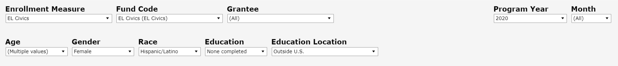

Step 2. Select Data
Click on the visualization you would like to download the data for by clicking on it. There will be no visible change even though it is selected.

Step 3. Click the download symbol
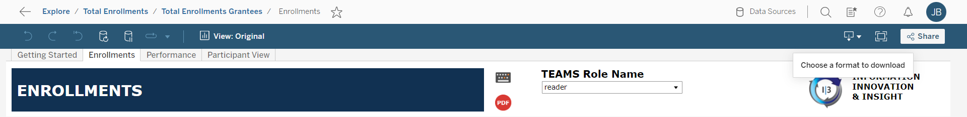

Step 4. Click “Data”
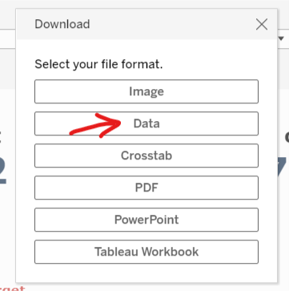

Step 5. Download File
Click “Full Data,” check “Show all columns,” and then click “Download all rows as a text file.” 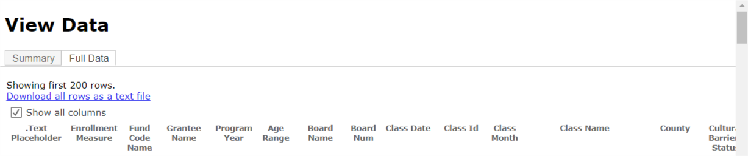

Step 6. Open File
After the file downloads, browse to your Downloads folder and open the file. Follow TWC PII guidance when working with student/participant data.

Dashboard PDF Download
For PDF download of the dashboard without filters applied, click the red PDF icon in the dashboard header.
For a PDF download of the dashboard with filters applied, follow the steps below.

Step 1
Set the filters.

Step 2
Click the download symbol in Tableau controls bar.

Step 3
Select “PDF” from the pop-up menu.
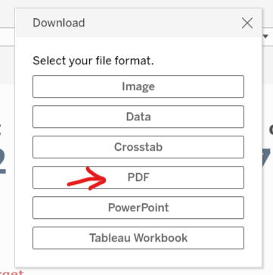

Step 4
In the Download PDF pop-up, you can leave all settings at default except for “Orientation,” which should be set to “Landscape.”
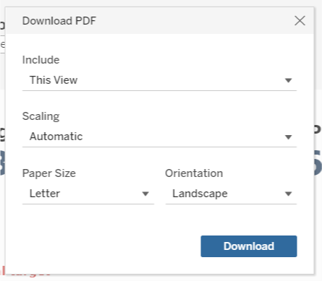

Step 5
The PDF will be downloaded and can now be opened from your Downloads folder.

Additional information can be found beginning page 19 at the following link: https://tcall.tamu.edu/docs/TEAMSResources/InstructionsForAELEnrollmentForm-TEAMSRelease5-4-1.pdf

